

**MINI-PROJECT REPORT**

**On**

**“IoT Based Forest Fire Detection System”**

**BACHELOR OF ENGINEERING**

**IN**

**INFORMATION SCIENCE AND ENGINEERING**

**Submitted by**

**Nandini Poddar (1DS19IS063)**

**Neha S Shetty (1DS19IS064)**

**Pankaj Garg (1DS19IS066)**

**Saquib Ameer Khan (1DS19IS089)**

**Guide:**

**Prof. Vaidehi M**

**Asst. Professor**

**Mentor:**

**Dr. Reshma J**

**Asst. Professor**

**Department Of Information Science and Engineering**

**DAYANANDA SAGAR COLLEGE OF ENGINEERING**

S M Hills, Kumaraswamy Layout, Bengaluru-560078

**2020-21**

**CONTENTS**

Abstract

Chapter1 Introduction….………………………………Pg No. 5-8

* 1. Introduction
  2. Problem statement
  3. Objectives and Scope of Project
  4. Motivation of Project

Chapter 2 Literature Survey……………………………. Pg No. 9-10

Chapter 3 Requirements …………………………………Pg No. 11

3.1 Software Requirements

3.2 Hardware Requirements

Chapter 4 System Design …………………………………Pg No. 12-17

4.1 Existing system

4.2 Proposed system

4.3 System Architecture

Contribution

Chapter 5 Conclusion ……….……………………………Pg No. 19-20

Reference

**ABSTRACT**

Fire, as one of the world's biggest calamities, must be identified at the right moment before it can do significant damage to the atmosphere, living beings and resources. In one way or another, these renewable resources are very essential to mankind. Forest fires are the most common hazards in forests which lead to serious destruction of forest wealth, biodiversity and natural habitat. According to a study, 75-80 percent of the various casualties caused by fire might have been prevented if the misfortune was detected quickly. Particularly in the case of a forest fire, this results in a significant loss to the environment and makes it extremely dangerous for the wildlife habitat. To avoid such losses, an automated system is needed that can provide early detection of any fire situation via any of the alarm systems.

In order to achieve early detection, there are two most used traditional methods of human surveillance.

* Human observation
* Automation approach

Traditional methods of human surveillance are directly through human observation and through distant video surveillance. This requires 24/7 continuous monitoring. The automated fire alert detection system by which one can achieve surveillance through the automation approach of detection proposed in this project comprises three sensors, namely flame, temperature (DHT) and CO2 MQ135. These sensors detect change in a measurable physical quantity and intimate the nearest fire extinguishing station.

Internet of Things (IoT) technology has brought revolution to each and every field of common man’s life by making everything smart and intelligent. IoT refers to a network of things which make a self-configuring network. The development of IOT based Forest Fire Detection System will be helpful in mapping emergency plans and making them more effective during the occurrence of any disaster. In this project, the intention is to build a Forest fire detection system using IoT which would detect the fire and send an emergency alert to the Authority through IoT. Here a GSM/GPRS module is used to communicate with IoT servers.

**Chapter 1**

**1.1 INTRODUCTION**

A wildfire, forest fire, bushfire, wild-land fire or rural fire is an unplanned, uncontrolled fire in an area of combustible vegetation starting in rural and urban areas. Of late, forest fires have captured the attention of people worldwide. Over the last few years there have been devastating fires in the forests of South east Asia, Amazon and the Rocky Mountains of the USA. Such fires have not only led to threats to the biological diversity of these forests, but have also caused large-scale human suffering in neighboring lands, due to pollution of the environment.

Forests play an important role in the global, ecological, environmental and recreational system. It greatly impacts the amount of greenhouse gasses, atmospheric carbon absorption, and reduces soil erosion. Forests contain many essential resources for human survival and social development that protect the balance of the Earth ecosystem. Forest fires are a recurrent phenomenon, natural or man-made, in many parts of the world. Global warming contributes to the increase in its number in recent years and the importance of these disasters. In this scenario, the frequency of forest fires has increased considerably due to climate change, human activities and other factors.

The detection and monitoring of forest fires has become a global concern in forest fire prevention organizations. This system can monitor real-time related parameters, e.g., temperature, relative humidity, and send the data immediately to the computer of the monitoring center. The fire alert system has low power utilization and quicker handling capacity at a lower cost and maintenance.

The Forest fire detection system uses advanced technology which will help in tracing out the forest ﬁre in its initial stage. The development of IOT based Forest Fire Detection System will be helpful in mapping emergency plans and making them more effective during the occurrence of any disaster.

**1.2 PROBLEM STATEMENT**

Lately the world has seen many occurrences of wildfires which have caused a lot of damage to our biodiversity. These fires have caused damage to wildlife, human life, property and environment. It could be avoided if a robust system could be deployed in forest areas to detect the fire in its initial stage and alert the concerned authority to take appropriate and immediate action.

Hence our approach addresses the need for an early detection of the forest fire before it spreads to a large scale and causes a number of casualties. As a result of this automated system, a lot of lives as well as the natural resources could be saved. The approach ensures a more reliable and accurate result and is cost effective at the same time.

* 1. **OBJECTIVES AND SCOPE**

The main objective of this proposed model is to predict the developing trend of the fire by building a Forest fire detection system using IoT and cloud which would detect the fire and send an emergency fire alert to the authority and analyze the growth of the fire for future study.

The objective is to detect the fire as fast as possible and its exact localization and early notification to the fire units is vital. This is the deficiency that the present Invention attempts to remedy, by means of detection of a forest fire at the very early stage, so as to enhance or ensure the chance to put it out before it has grown beyond control or causes any significant damage.

There are a number of detection and monitoring systems used by authorities. These include observers in the form of patrols or monitoring towers, aerial and satellite monitoring and increasingly promoted detection and monitoring systems based on optical camera sensors, and different types of detection sensors or their combination.

The scope of the proposed model is

* To detect the forest fire at its early stages.
* To determine the intensity of the forest fire.
* To intimate the respective authority along with the GPS coordinates of the location.
* Alert the surrounding ecosystem with a fire alarm.
* Then analyze the change in measurable physical quantity.

Millions of hectares of forest are destroyed by fire every year. Areas destroyed by these fires are large and produce more carbon monoxide than the overall automobile traffic. Monitoring of the potential risk areas and an early detection of fire can significantly shorten the reaction time and also reduce the potential damage as well as the cost of firefighting. The objective is to detect the fire as fast as possible and its exact localization and early notification to the fire units is vital. This is the deficiency that the present Invention attempts to remedy, by means of detection of a forest fire at the very early stage, so as to enhance or ensure the chance to put it out before it has grown beyond control or causes any significant damage.

**1.4 MOTIVATION OF THE PROJECT**

**Dixie:** California's Dixie fire was the largest wildfire of 2021. It burned more than 960,000 acres before being contained. More than 7.6 million acres burned in the US in 2021 due to wildfires. That's about 2.6 million fewer acres than 2020.

**Black Summer:** Australia’s “Black Summer” bushfire was another such devastating incident. More than 24 million hectares (59 million acres) burned during the bushfire season of 2019-2020, which formed part of a confirmed climate change-driven trend of worsening fire weather and larger, more intense forest fires.

One of the most dangerous aspects of wildfires is their ability to spread quickly and wipe out critical habitat. Wildfires can burn through a forest at a speed of 10 kilometers (6 miles) an hour.

The forest cover is also necessary in the environment as it is a source of food and other materials and also to keep the green cover of the planet alive and the environment clean.

Reduce the emission of harmful greenhouse gasses like carbon-dioxide, carbon monoxide, methane, etc. during these forest fires.

Smoke from forest fires rise into the atmosphere, causing a set of chemical reactions leading to the loss of ozone layer, which shields the Earth from harmful UV rays.

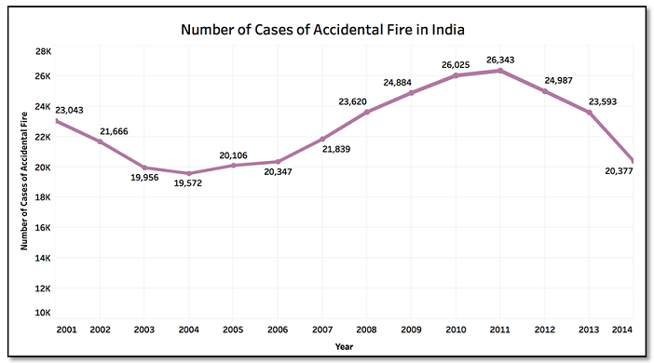

Fig. 4.1: Forest Fire Cases in India

**Chapter 2**

**LITERATURE SURVEY**

Numerous solutions have been proposed and implemented for this problem. Most common systems used in field work are video surveillance systems. Video cameras are sensitive to smoke only in the daytime. Fire sensitive cameras at night, using IR thermal imaging cameras for heat flux detecting and using backscattering of laser light, detect the smoke particles. This fire alert system has a few limitations because of environmental conditions like dust particles, mist, shadows and so on. Another method is automated picture capturing of fires in the forest.

Capturing can be done by the cameras which are placed on top of towers. A motor was introduced to give a coverage view on the forest and for its movement (Basu et al., 2018). Captured pictures are processed using program or MATLAB simulation and matching with references taken at the beginning stage. This alert system has a limitation of false caution rate and visual cameras installed on towers are of high cost. Another method of fire detection is by using satellite systems. Base station collects the information sent by the satellite and runs an algorithm to recognize the facts (Basu et al., 2018). The raw data of satellites are processed and then the Advanced Very High-Resolution Radiometer instrument is utilized to recognize hotspots. In South Korea, a forest fire surveillance system was proposed by using wireless sensor networks. Wireless sensor networks detect humidity and an application analyses the collected information (Hariyanwal et al., 2013; Kumar et al., 2017).

In this methodology, there is some loss of information during communication. By using a temperature sensor and GPS modem, forest fire detection can be possible (Basu et al., 2018). Here, temperature sensors collected data were sent to the base station by both primary and main antennas (Alahi et al., 2017). Continuous power supply was difficult for too many antennas and sensors. In addition to the above limitations climatic changes may affect the system. In research done by Zhang et al. (2009), Pirbhulal et al. (2017), and Alahi et al. (2017) an ad hoc network using cluster topology for forest fire forecasting model was used to predict fire prone areas.

It was concluded that WSNs have greater advantages. In another research done by Demin et al. (2014), sensors were deployed and the weather data were collected. This data was used to calculate and prevent forest fires. In these researches, there was no real-time forest fire monitoring, only the data were collected and fire prone areas were predicted. Libelium (Solobera, 2010) developed a wasp mote which has four sensors for measuring gases, temperature and humidity. It gives early warnings and consumes very less energy.

Shunyang X. Du, J. Yongping and W. Riming, Realization of Home Remote Control Network Based on Zigbee (2007), et al. deals with the design of remote monitoring and controlling systems. The system consists of a real-time home monitoring subsystem and a light control sub-system. A home server with a home camera caters for home status through video to client.

A program that analyzes satellite data in near real time and converts information into instant messages and email alerts to track forest fires. ICIMOD helped design a system that uses satellite data to monitor and assess the damage of forest fires and then automatically sends SMS messages and emails to district forest officers and rangers so they are better able to monitor a fires growth and direction and alert populations when there may be a need to evacuate, L.N.Wang, et al. (avoid fire accidents on running trains using ZigBee wsn) proposed this system to avoid fire in running trains. When fire is noticed in any compartment, the temperature sensor senses the fire by the difference between the coach temperature and the critical temperature.

**Chapter 3**

**Requirements**

* 1. **Software Requirements**
* Arduino IDE (1.8.13)
* ThingSpeak Account (Cloud)
* Software Serial

**3.2 Hardware Requirements**

* Arduino UNO
* SIM808 GPS/GPRS/GSM Module
* Sensors-
  + Flame
  + DHT
  + CO2 MQ135
* Buzzer, LEDs
* 9V- 1A Battery
* Breadboard
* 5 V DC power supply
* Jumper wires and cables

**Chapter 4**

**System Design**

**4.1 Existing System**

There are various existing technologies to detect forest fires in its early stages. Few of them are mentioned below.

## Satellite-Based Systems

Earth-orbiting satellites and even air-floating devices have been employed for observation and detection of forest fires. Satellite images gathered by two main satellites launched for forest fire detection purposes, the advanced very high-resolution radiometer (AVHRR), launched in 1998, and the moderate resolution imaging spectroradiometer (MODIS), launched in 1999, have been used. Unfortunately, these satellites can provide images of the regions of the earth every two days and that is a long time for fire scanning; besides the quality of satellite images can be affected by weather conditions.

## Optical Sensor and Digital Camera

Nowadays, two different types of sensor networks are available for fire detection, camera surveillance and wireless sensor network. The development of sensors, digital cameras, image processing, and industrial computers resulted in the development of a system for optical, automated early recognition and warning of forest fires.

## Wireless Sensor Networks

The line of sight and the early stage of the fire process problem could be solved with the second type of sensors. A new technology called wireless sensor network (WSN) is nowadays receiving more attention and has started to be applied in forest fire detection. The wireless nodes integrate on the same printed circuit board, the sensors, the data processing, and the wireless transceiver and they all consume power from the same source batteries. Unlike cell phones, WSN does not have the capability of periodic recharging.

## Authorities Fire Suppression and Detection Techniques

Some of the techniques used in fire suppression include burning dry areas under the management of fire fighters rather than having a crisis later or using flying water tankers like in Canada. Interestingly, others sweep away everything within a planned wide line to surround the fire with a dead end of unfilled areas like in the Middle East. In some parts of Australia, providing the fire does not harm any humans or properties, it is left to burn, until it dies alone.

**4.2 Proposed System**

This section of the report will include the proposed work as to how the project has been carried out showing the Hardware used, Software’s utilized, Algorithms used with respect to deep learning part of the project and working of the project.

As shown in the schematic block diagram below, the project consists of Arduino UNO, SIM808 GSM/GPRS module and sensors like flame sensor, DHT11 (Temperature and Humidity) sensor and MQ135 (CO2 sensor) as its primary components. The fire can be detected by the sensors which gives a digital output that corresponds to the Fire status and is received by the Arduino UNO.

Arduino compares the signal and triggers the SIM808 in case of fire incidents. Through AT commands, SIM808 communicates with the thingspeak server.

Fire alert system comprises three important stages: sensing, routing and communication. For sensing the physical change in environment, a couple of sensors are used, namely smoke and fire sensors.

The fire and smoke sensors detect the respective elements and this initializes an alert and activates the system. This, in turn, sends the location, which is detected by the GPS module, with an alert message via SMS to the user with the help of the GSM module that has been incorporated into the system. Once the user receives the alert message, the required action can be taken to control and cease the fire.

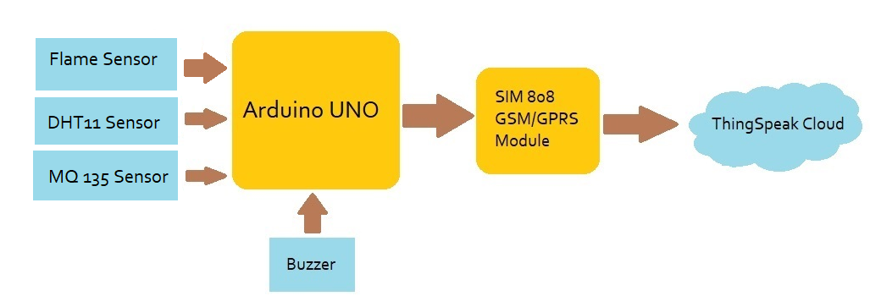

Following steps are followed:

* Connect the Flame sensor, DHT sensor and the CO2 sensor to the microcontroller (Arduino UNO) using Jumper wires and breadboard.
* Also connect SIM808 module via Logic shifting resistors.
* Connect the buzzer and LEDs for the alarming system.
* Supply DC current (9V-1A) to SIM808 module to power it on.
* 5V DC external supply is given to Arduino UNO for the working of UNO and the sensors.
* After successful integration of hardware, Arduino IDE is used to code those components. and get the required readings.
* Cloud platform needs to be set up, where the real-time data will be received.
* Once all the data is received, the intensity of the fire will be estimated and the level of the wild fire will be determined.

After successful completion of hardware as per the above circuit diagram, the IoT platform needs to be set up, where the real-time data will be received. Here Thingspeak is used to store the parameters and show them in GUI.

For setting up the Thingspeak account follow the steps below:

* + First, go to <https://thingspeak.com/> and create a new free Mathworks account if you don’t have a Mathworks account before.
  + Sign in to Thingspeak using your credentials and click on “New Channel”. Now fill up the details of the project like Name, Field names, etc. Then click on “Save channel”.
  + Record the Credentials
  + Select the created channel and record the following credentials.
  + Channel ID, which is at the top of the channel view.
  + Write API key, which can be found on the API Keys tab of your channel view.
  + Add widgets to your GUI
  + Click on “Add Widgets” and add four appropriate widgets like gauges, numeric displays, and indicators. In my case, I have taken the Indicator for Fire Alert. Select appropriate field names for each widget.

**4.3 System Architecture**

This section describes the architecture of a basic fire detection system that can be thought of close to a practical system using any one of the techniques. Fig 3a describes the architecture of a system which can be implemented for fire detection if the region of interest for detection is limited. Example of a limited region of interest may be a village in the middle of a forest or a building surrounded by dense trees. In such a case a k-barrier coverage technique as discussed in. In this fire is treated as an intrusion between two fixed points and nodes will be placed on points which are orthogonal to it. Barriers will be formed between these two nodes as shown in the figure. If any intrusion happens from any one of the fixed points, then it can be detected by the barrier network. The nodes placed on the orthogonal points are called virtual nodes and the path established between these two virtual nodes will result in communication between physically existing nodes along the paths.

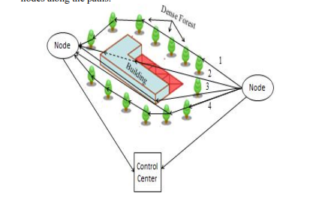

* The leader node analyses data from all the slave nodes in its cluster and if there is a fire at any node. When the master node successfully receives data from slave node, the LCD display turns ON and displays “FIRE ALERT”, then it will immediately communicate with the base station using GSM modem.
* This alert gets transmitted to the user via SMS by GSM modem with help of GPS for location.
* GSM can receive and send messages and it can be interfaced to a computer or to a microcontroller. GSM and GPS modules have a very wide coverage and are very energy efficient.
* GPS is used to send location. The base station is alerted immediately when a node detects fire with location.

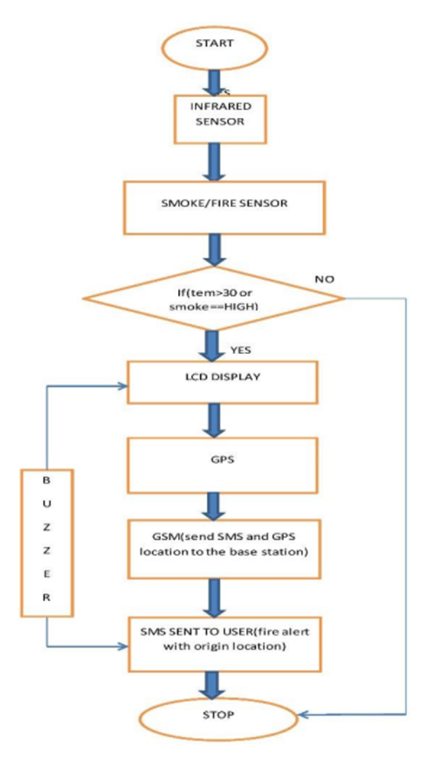

It is basically a cluster-based network where a group of sensor node form a cluster and a central node will act as a cluster head. Sensor node will have limited range communication ability where as a cluster head i.e., central node can communicate directly with the control center which can be either situated near to the forest under surveillance or it can also be situated remotely very far from the forest under surveillance.

**5.CONTRIBUTION**

The problem with forest fires is that the forests are usually remote, abandoned/unmanaged areas filled with trees, dry and parching wood, leaves, and so forth that act as a fuel source. These elements form a highly combustible material and represent the perfect context for initial-fire ignition and act as fuel for later stages of the fire. The fire ignition may be caused through human actions like smoking or barbeque parties or by natural reasons such as high temperature in a hot summer day or a broken glass working as a collective lens focusing the sunlight on a small spot for a length of time thus leading to fire-ignition.

Once ignition starts, combustible material may easily fuel to feed the fires central spot which then becomes bigger and wider. The initial stage of ignition is normally referred to as “surface fire” stage. This may then lead to feeding on adjoining trees and the fire flame becomes higher and higher, thus becoming “crown fire.”

The forest fire detection system can be used to locate the high-risk areas before the outbreak of fires and prevent casualties and property losses.

Monitoring of the potential risk areas and an early detection of fire can significantly shorten the reaction time and also reduce the potential damage as well as the cost of firefighting.

A fire-detection system can limit the emission of toxic products created by combustion, as well as global-warming gasses produced by the fire itself.

Reduce losses for natural hazards and prevent man-made hazards (forest arsons) from happening.

Contribute to the protection of cultural heritage, the basic asset on which tourism is built. Tourism, closely related to Cultural Heritage, is, at the moment, the main industry in the world, with an increasing ratio of 12% of the Gross Domestic Product (GDP). This sector employs 8 million people in Europe and accounts for nearly 5.5 % of European GDP.

**6.CONCLUSION**

Early cautioning and quick reaction to a fire breakout are the main approaches to dodge incredible misfortunes and natural and social legacy harms. Hence, the most critical objectives in flame observation are fast and solid identification and restriction of the fire. It is substantially less demanding to stifle a fire when the beginning area is known, and keeping in mind that it is in its beginning periods. Data about the advance of flame is likewise profoundly profitable for dealing with the fire amid every one of its stages. In light of this data, the fire battling staff can be guided on focus to hinder the fire before it achieves social legacy destinations and to smother it rapidly by using the required putting out fires’ hardware and vehicles.

The improved system can be deployed for tenement appliances and in industries also. However, the system above is meant for sincere opinion news only. As a tomorrow aggravation, several-decision companies through the IOT landing are studying an object and the exploration is being done to effectuate this enormous toil. It is true that with the technological advancements profitable in the instant age scenario, the above rehearsed several-opinion correspondence will also unfold in aqiqiy delay environments.

The fire and smoke sensors detect the respective elements and this initializes an alert and activates the system. This, in turn, sends the location, which is detected by the GPS module, with an alert message via SMS to the user with the help of the GSM module that has been incorporated into the system. Once the user receives the alert message, the required action can be taken to control and cease the fire. The wireless transmission using RF, from one node to another node was experimented up to 100 m. As there would not be any obstructions in the forest, the RF modules can work up to half a kilometer efficiently. For the GSM module to work properly, there should be a minimum network coverage to send an SMS with location. The nodes can be placed 500 m away from each other, for maximum coverage of the forest area with minimum number of nodes and to perform with good efficiency. Sleep-based topologies are also included so as to reduce energy consumption. The master node must have a bigger battery, because the GSM module consumes higher energy. The fire and smoke sensors were tested up to 10m.

The system thus intended is powerful to expose the mixture variations, daring gasses and fire event through the sensors in diligence and powerful to update the complaint to the style expert through the IOT fulfill secondhand MQTT policy.

**7.REFERENCES**

* F. Akyildiz, W. Su, W. Sankarasubramaniam, and E. Cayirci, A survey on sensor networks, Bulusu, J. Heidemann, and D. Estrin. GPS-less low-cost outdoor localization for very small devices.
* IEEE Personal Communications,7(5):2834, 2000. Special Issue on Smart Spaces and Environments.
* D. M. Doolin and N. Sitar. "Wireless sensor for wildfire monitoring Proceedings of SPIE Symposium on Smart Structures & Materials”, NDE 2005, San Diego, California, March 6-10, 2005
* Wireless sensor network for forest fire detection.Telkomnika, 11 (3) (2013), p. 563, Mohapatra S., Khilar P.M.
* Fault Diagnosis in Wireless Sensor Network Using Self/Non-self-Discrimination Principle. Progress in Computing, Analytics and Networking, Springer, Singapore (2020), pp. 161- 168Saidi H., Gretete D., Addaim A.
* Game Theory for Wireless Sensor Network Security Fourth International Congress on Information and Communication Technology, Springer, Singapore (2020), pp. 259- 269 Aliady W.A., Al-Ahmadi S.A
* Base Papers:
  + **IEEE**- <https://ieeexplore.ieee.org/document/8878808>
  + **Circuitdigest**-<https://circuitdigest.com/microcontroller-projects/iot-based-forest-fire-detection-using-arduino-and-gsm-module>
  + **IRJET**- <https://www.irjet.net/archives/V8/i4/IRJET-V8I4360.pdf>
  + **ManxTechgroup**-[https://www.manxtechgroup.com/forest-fire-detection-using-iot-and-co2-sensors](https://www.manxtechgroup.com/forest-fire-detection-using-iot-and-co2-sensors/)